5

Analyses of Axisymmetric Bodies

Exercise 1

* Create the profile of the cylindrical vessel (say on the Top Plane), then revolve it for just 90 degrees.

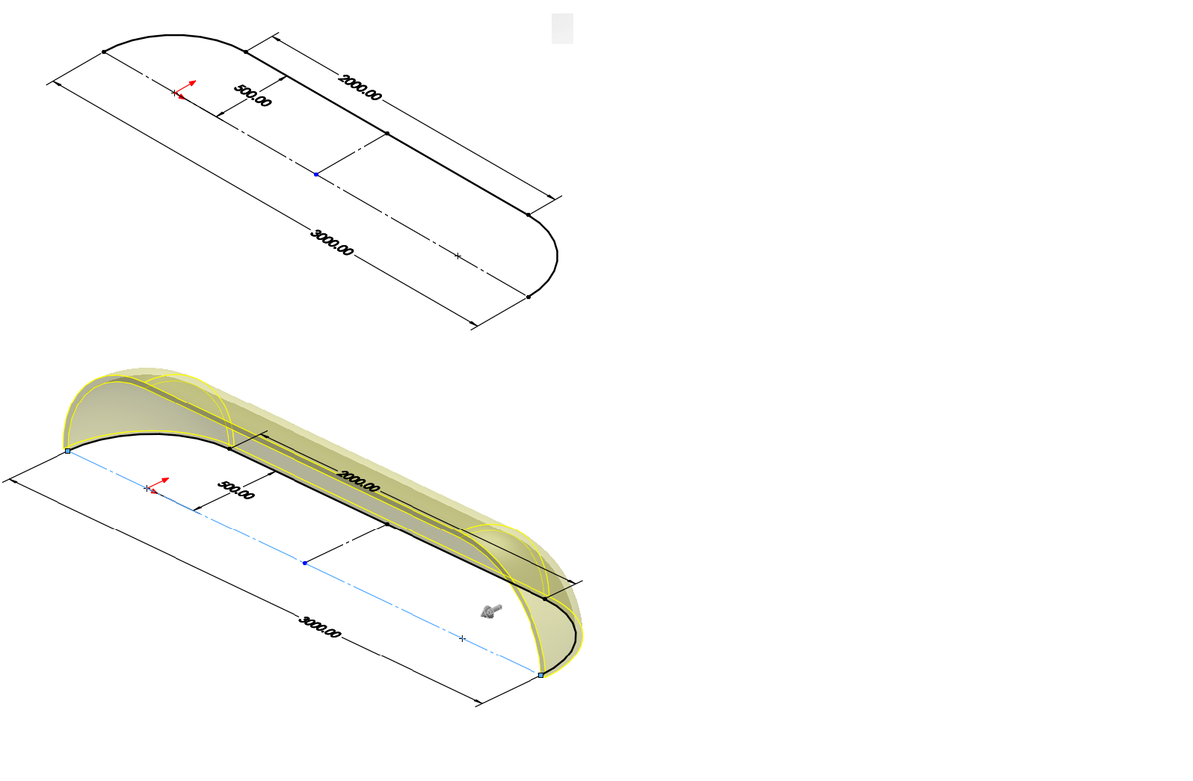

* Create a surface body from the partially-revolved body using the **Surface Offset** command.
* Complete the simulation study
  + Define shell thickness and ensure the **thin shell assumption** is used
  + Apply material (AISI Type 316L)
  + Apply constraint (symmetric boundary conditions using the **Reference Geometry Option**)
  + Apply the internal pressure
  + Run the study to get the solutions/results
    - The plot of the solution displaying the distribution of the hoop stress (First principal stress) is shown below:

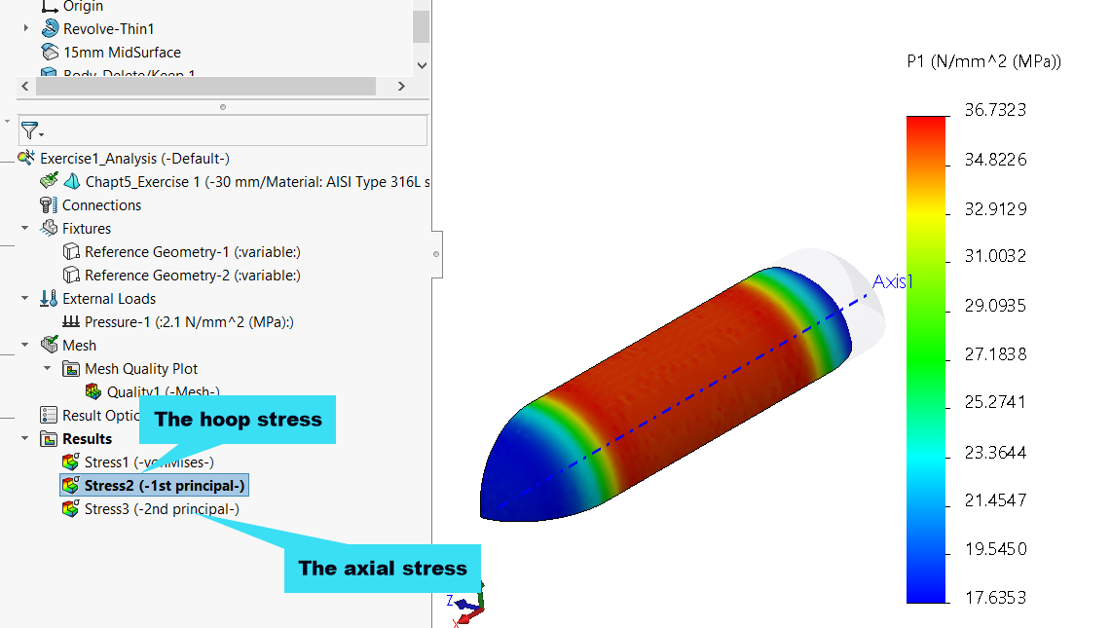

* Use the **Probe** tool to obtain the average value of the hoop stress as:

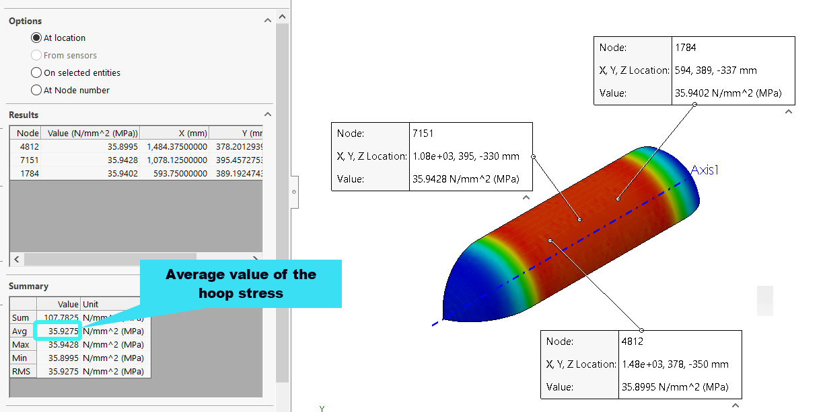

* Use the **Probe** tool to obtain the average value of the axial stress as:

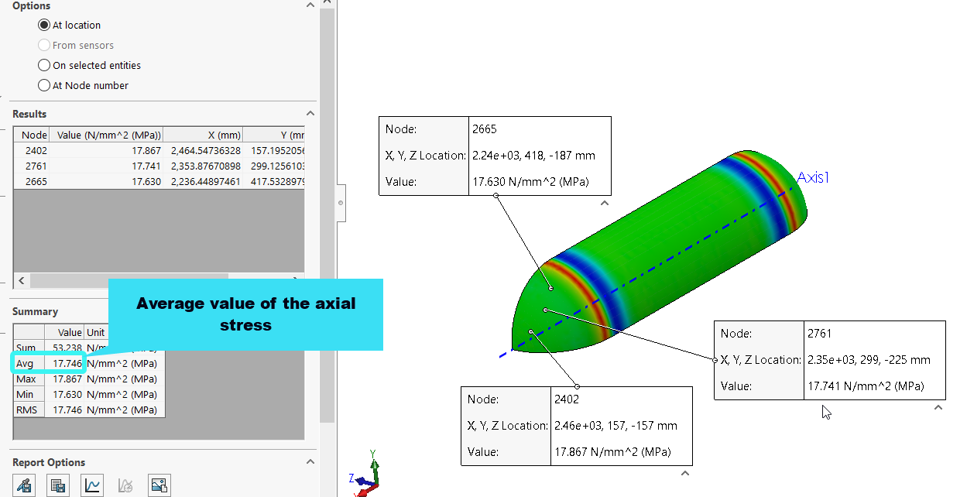

Exercise 2

* Generate the surface model of the circular plate by:
  + Creating a circular sketch
  + Employing **Insert 🡪 Surface 🡪 Planar** to create the surface
* Create the simulation set-up:
  + Define the thickness of the plate
  + Create and apply a new material based on the given properties of **polycarbonate**

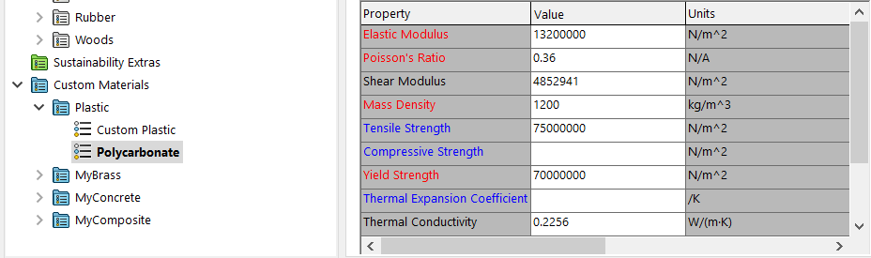

* + Apply a fixed boundary condition around the edge of the plate

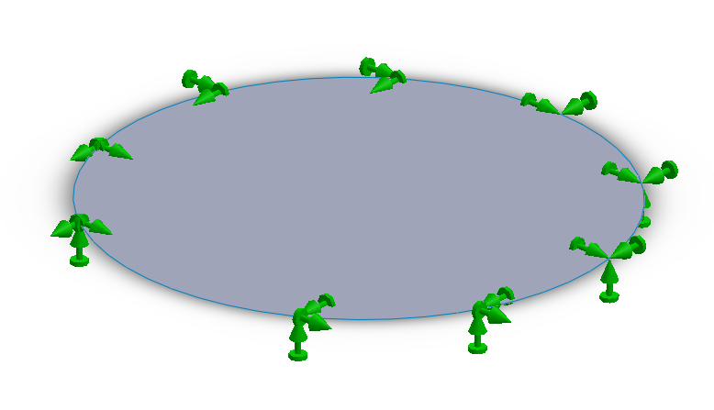

* + Apply the external load (a uniform pressure of 0.2 kPa)

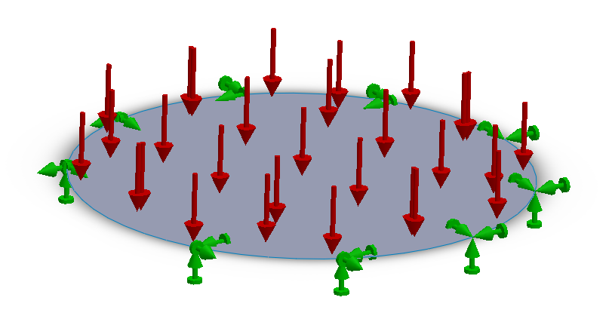

* Run and obtain the results:
  + **Maximum deflection along the Y-axis**

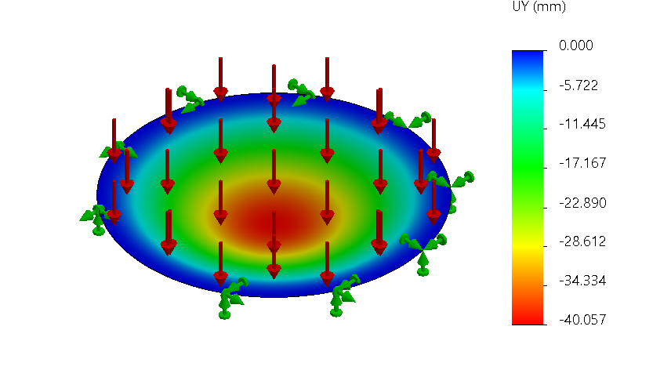

* + **Maximum principal stress**

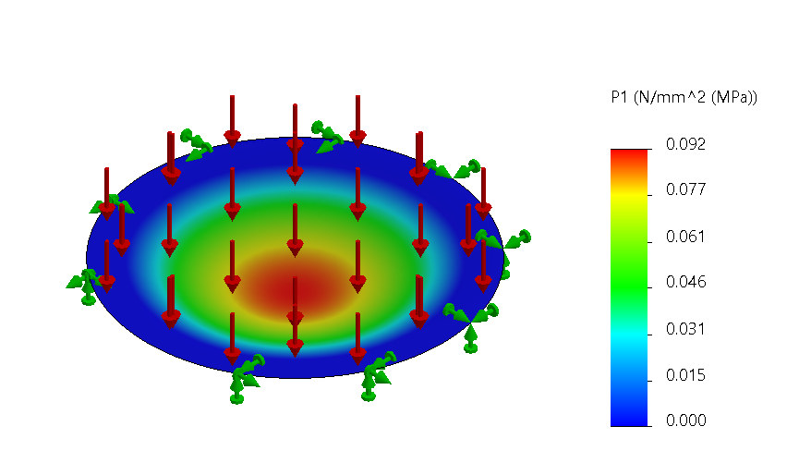

Exercise 3

* Modify the geometry of case study 2 such that the thickness is 100 mm is shown below:

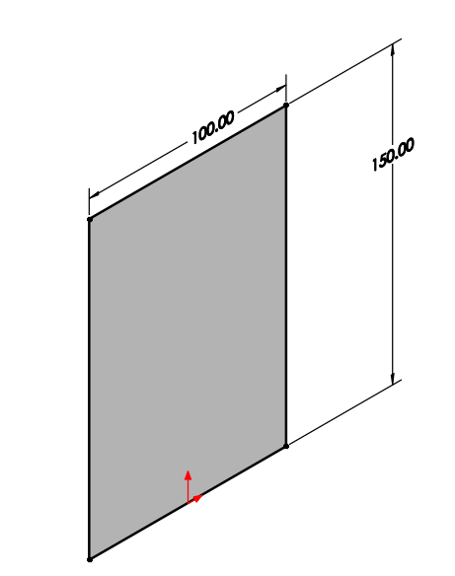

* Re-run the analysis, then obtain the distribution of the factor of safety:

